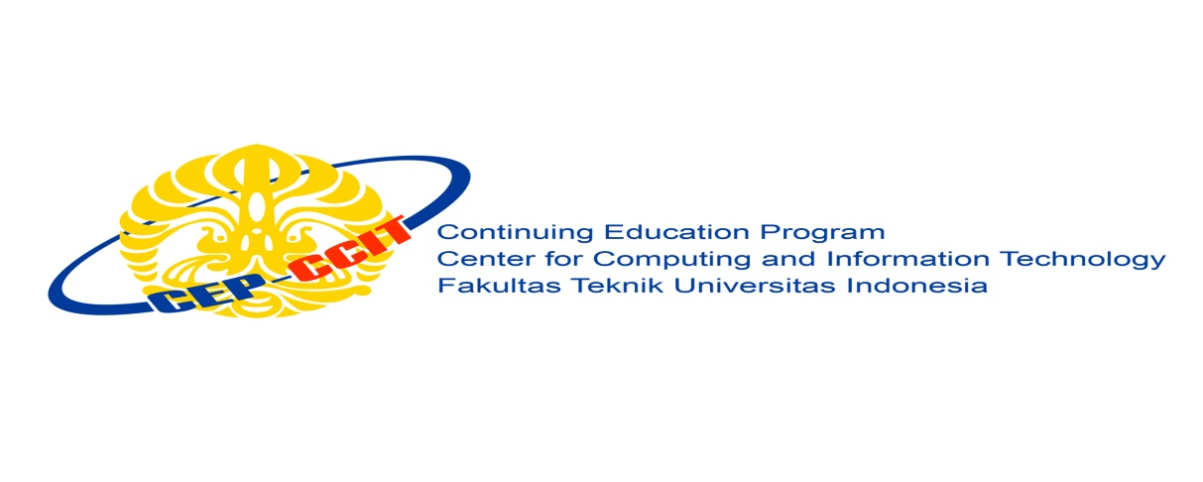

**Information Search and Analysis Skills**

**(ISAS)**

**Main Memory and Virtual Memory on Windows 10**

Name : 1. Hilman Maulana Anhar

2. Muhamad Dani Setiawan

Faculty : Listyo Edi Prabowo, ST.

Semester : 1

Quarter : 2

Class : 1SC8

Continuing Education Center for Computing and Information Technology Faculty of Engineering, University of Indonesia

2018

**PREFACE**

Praise be to Allah Almighty, Most Merciful, because thanks to His grace and guidance, the writer can arrange and present a paper entitled “Main Memory and Virtual Memory on Windows 10”. The writer also thanked to Mr. Listyo Edi Prabowo, ST. as our faculty that have provided guidance to the writer in the process of preparing this paper. Not to forget the writer thank the various parties who have given encouragement and motivation.

The author realizes that in the preparation of this paper there are still many shortcomings and far from perfection. Therefore, the authors expect constructive criticism and suggestions to improve this paper and can be a reference in preparing the papers or subsequent tasks.

The authors also apologize if in writing this paper there are typos and errors that confuse the reader in understanding the author's intent.

**Writer**

**TABLE OF CONTENTS**

PREFACE i

TABLE OF CONTENTS ii

TABLE OF FIGURES iii

TABLE OF TABLES iv

CHAPTER I INTRODUCTION

1. Background
2. Writing Objective
3. Problem Domain
4. Writing Methodology
5. Writing Framework

CHAPTER II BASIC THEORY

1. Definiton of Operating System
2. Explanation About Windows 10
3. Explanation About Main Memory
4. Explanation About Virtual Memory

CHAPTER III PROBLEM ANALYSIS

1. Main Memory on Windows 10
2. How to Manage Virtual Memory on Windows 10
3. Memory Management on Windows 10

CHAPTER IV CONCLUSION AND SUGGESTION

1. Conclusion
2. Suggestion

BIBLIOGRAPHY

**TABLE OF FIGURES**

Figure 3.1 User Interface of Cinnamon Linux Mint OS 12

Figure 3.2 User Interface of Mate Linux Mint OS 13

Figure 3.3 User Interface of XFCE Linux Mint OS 13

Figure 3.4 User Interface of KDE Linux Mint OS 14

**TABLE OF TABLES**

Table 3.1 Version of Linux Mint OS 8

**CHAPTER I**

**INTRODUCTION**

1. **Background**

Windows is a series of operating systems developed by Microsoft. Each version of Windows includes a graphical user interface, with a desktop that allows users to view files and folders in windows. For the past two decades, Windows has been the most widely used operating system for personal computers PCs.

Microsoft Windows is designed for both home computing and professional purposes. Version to version of Windows are Windows 3.0, Windows 3.1, Windows 95, Windows 98, Windows Me, Windows XP, and Windows Vista, Windows 7, Windows 8, and Windows 10, is an up-to-date and stable version.

The first business-oriented version of Windows, called Windows NT 3.1, was in 1993. This was followed by Windows 3.5, 4.0, and Windows 2000. When Microsoft released Windows XP in 2001, the company simply created different editions of the operating system for personal and business purposes. Windows 10 has followed the same release strategy.

Windows is designed to run on standard x86 hardware, such as Intel and AMD processors. Therefore, it can be installed on multiple brands of hardware, such as Dell, HP, and Sony computers, as well as home-built PCs. Windows 10 also includes several touchscreen features, that allow the operating system to run on certain tablets and computers with touchscreen displays. Microsoft's mobile operating system, Windows Phone, is designed specifically for smartphones and runs on several brands of phones, including HTC, Nokia, and Samsung.

In this ISAS, we will explain Security System and Protection System on Windows 10. And also, explain what are external softwares on Windows 10 which can support to secure and protect data and when we are exploring internet.

1. **Writing Objective**

The purposes of writing this ISAS is to get better knowledge about Windows Operating System, especially Windows 10. Also, to get more information about Main Memory and Virtual Memory on Windows 10.

1. **Problem Domain**

The problem that we are going to discuss in this ISAS are Definition of Operating System, Explanation About Windows 10, Explanation About Main Memory and Virtual Memory on Windows 10.

1. **Writing Methodology**

The method used is the method of research with data collection techniques using observations from reliable media and discussion by group.

1. **Writing Framework**

**CHAPTER I INTRODUCTION**

* Background
* Writing Objective
* Problem Domain
* Writing Methodology
* Writing Framework

**CHAPTER II BASIC THEORY**

* Definition of Operating System
* Explanation About Windows 10
* Explanation About Main Memory
* Types of Main Memory
* Explanation About Virtual Memory
* Types of Virtual Memory

**CHAPTER III PROBLEM ANALYSIS**

* Main Memory on Windows 10
* Virtual Memory on Windows 10

**CHAPTER IV CONCLUSION AND SUGGESTION**

* Conclusion
* Suggestion

**BIBLIOGRAPHY**

**CHAPTER II**

**BASIC THEORY**

1. **Definition of Operating System**

An operating system (OS) is the program that, after being initially loaded into the computer by a [boot](https://searchwindowsserver.techtarget.com/definition/boot) program, manages all the other programs in a computer. The other programs are called *applications* or application programs. The application programs make use of the operating system by making requests for services through a defined application program interface. In addition, users can interact directly with the operating system through a user interface such as a command line or a graphical user interface.

An operating system performs these services for applications:

* In a [multitasking](https://whatis.techtarget.com/definition/multitasking) operating system where multiple programs can be running at the same time, the operating system determines which applications should run in what order and how much time should be allowed for each application before giving another application a turn.
* It manages the sharing of internal memory among multiple applications.
* It handles input and output to and from attached hardware devices, such as hard disks, printers, and dial-up ports.
* It sends messages to each application or interactive user (or to a system operator) about the status of operation and any errors that may have occurred.
* It can offload the management of what are called *batch* jobs (for example, printing) so that the initiating application is freed from this work.
* On computers that can provide parallel processing, an operating system can manage how to divide the program so that it runs on more than one processor at a time.

All major computer platforms (hardware and software) require and sometimes include an operating system, and operating systems must be developed with different features to meet the specific needs of various [form factors](https://whatis.techtarget.com/definition/form-factor).

Common desktop operating systems:

1. [**Windows**](https://searchwindowsserver.techtarget.com/definition/Windows) is Microsoft’s flagship [operating system](https://whatis.techtarget.com/definition/operating-system-OS), the [de facto standard](https://whatis.techtarget.com/definition/de-facto-standard) for home and business computers. Introduced in 1985, the [GUI](https://searchwindevelopment.techtarget.com/definition/GUI)-based OS has been released in many versions since then. The user-friendly [Windows 95](https://whatis.techtarget.com/definition/Windows-95) was largely responsible for the rapid development of personal computing.
2. [**Mac OS**](https://whatis.techtarget.com/definition/Mac-OS) is the operating system for Apple's [Macintosh](https://whatis.techtarget.com/definition/Macintosh) line of personal computers and workstations.
3. [**Linux**](https://searchdatacenter.techtarget.com/definition/Linux-operating-system) is a [Unix](https://searchdatacenter.techtarget.com/definition/Unix)-like [operating system](https://whatis.techtarget.com/definition/operating-system-OS) that was designed to provide personal computer users a free or very low-cost alternative. Linux has a reputation as a very efficient and fast-performing system.

A [mobile OS](https://searchmobilecomputing.techtarget.com/definition/mobile-operating-system) allows [smartphones](https://en.wikipedia.org/wiki/Smartphone), [tablet PCs](https://searchmobilecomputing.techtarget.com/definition/tablet-PC) and other mobile devices to run applications and programs. Mobile operating systems include Apple [iOS](https://searchmobilecomputing.techtarget.com/definition/iOS), Google [Android](https://searchmobilecomputing.techtarget.com/definition/Android-OS), BlackBerry OS and [Windows Phone](https://whatis.techtarget.com/definition/Windows-10-Mobile).

1. **Explanation About Windows 10**

Windows 10 is a major version of the Microsoft Windows operating system that was released on July 29, 2015. It is built on the Windows NT kernel and follows Windows 8.

Part of the reason Microsoft decided to name the 2015 release "Windows 10" (and skipped "Windows 9") is because the operating system is designed to be a new direction for Microsoft. One of the primary aims of Windows 10 is to unify the Windows experience across multiple devices, such desktop computers, tablets, and smartphones. As part of this effort, Microsoft developed Windows 10 Mobile alongside Windows 10 to replaces Windows Phone – Microsoft's previous mobile OS. Windows 10 also integrates other Microsoft services, such as Xbox Live and the Cortana voice recognition assistant.

While Windows 10 includes many new features, it also brings back the Start Menu, which was dropped in Windows 8. The new and improved Start Menu provides quick access to settings, folders, and programs and also includes tiles from the Windows 8 interface. The bottom of the Windows 10 Start Menu includes a search bar that allows you to search both your local PC and the web.

Another major change in Windows 10 is the introduction of the "Edge" web browser, which is designed to replace Internet Explorer (IE). While the OS still includes IE, Edge is the default browser in Windows 10. Other new features include Continuum, which automatically optimizes the user interface depending on whether you are using an external keyboard or touchscreen, and Action Center, which is similar to the Notifications bar in OS X. Windows 10 also supports multiple desktops on a single monitor and provides Snap Assist, a feature that helps organize windows on the screen.

One of the biggest differences between Windows 10 and previous releases of Windows is that the Windows 10 upgrade is available for free to Windows 7 and Windows 8 users. However, Microsoft still charges a licensing fee for copies of Windows 10 shipped with new computers and for non-upgrade purchases. The full version of Windows 10 Home is available for $120 and Windows 10 Pro costs $200.

1. **Explanation About Main Memory**

Main memory refers to physical memory that is internal to the computer. The word main is used to distinguish it from external mass storage devices such as disk drives. Other terms used to mean main memory include RAM and primary storage.

The computer can manipulate only data that is in main memory. Therefore, every program you execute and every file you access must be copied from a storage device into main memory. The amount of main memory on a computer is crucial because it determines how many programs can be executed at one time and how much data can be readily available to a program.

Because computers often have too little main memory to hold all the data they need, computer engineers invented a technique called swapping, in which portions of data are copied into main memory as they are needed. Swapping occurs when there is no room in memory for needed data. When one portion of data is copied into memory, an equal-sized portion is copied (swapped) out to make room.

Now, most PCs come with a minimum of 32 megabytes of main memory. You can usually increase the amount of memory by inserting extra memory in the form of chips.

1. **Explanation About Virtual Memory**

Virtual memory is a memory management capability of an OS that uses hardware and software to allow a computer to compensate for physical memory shortages by temporarily transferring data from random access memory (RAM) to disk storage. Virtual address space is increased using active memory in RAM and inactive memory in hard disk drives (HDDs) to form contiguous addresses that hold both the application and its data.

Computers have a finite amount of RAM so memory can run out, especially when multiple programs run at the same time. A system using virtual memory can load larger programs or multiple programs running at the same time, allowing each one to operate as if it has infinite memory and without having to purchase more RAM.

As part of the process of copying virtual memory into physical memory, the OS divides memory into pagefiles or swap files that contain a fixed number of addresses. Each page is stored on a disk and when the page is needed, the OS copies it from the disk to main memory and translates the virtual addresses into real addresses.

**CHAPTER III**

**PROBLEM ANALYSIS**

1. **Main Memory on Windows 10**

Memory is the best essential element of a computer because computer can’t perform simple tasks. Computer memory is of two basic type – Primary memory / Volatile memory and Secondary memory / non-volatile memory. Random Access Memory (RAM) is volatile memory and Read Only Memory (ROM) is non-volatile memory.

1. 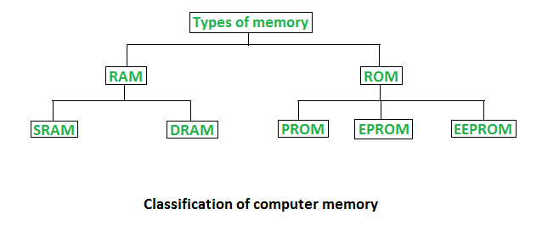**Types of Memory**
2. Random Access Memory (RAM)

* It is also called as *read write memory* or the*main memory* or the *primary memory*.
* The programs and data that the CPU requires during execution of a program are stored in this memory.
* It is a volatile memory as the data loses when the power is turned off.
* RAM is further classified into two types- *SRAM (Static Random Access Memory)*and *DRAM (Dynamic Random Access Memory)*.

|  |  |
| --- | --- |
| **DRAM** | **SRAM** |
| Constructed of tiny capacitors that leak electricity | Constructed of circuits smilar to D flip-flops |
| Requires a recharge every few milliseconnds to maintains its data | Hold its contents as long as power is available |
| Inexpensive | Expensive |
| Slower than SRAM | Faster than DRAM |
| Can store many bits per chip | Can not store many bits per chip |
| Uses less power | Uses more power |
| Generates less heat | Generates more heat |
| Used for main memory | Used for cache |

1. Read Only Memory (ROM)

* Stores crucial information essential to operate the system, like the program essential to boot the computer.
* It is not volatile.
* Always retains its data.
* Used in embedded systems or where the programming needs no change.
* Used in calculators and peripheral devices.
* ROM is further classified into 4 types- *ROM*, *PROM*, *EPROM*, and *EEPROM*.

1. Types of Read Only Memory (ROM)

* **PROM (Programmable read-only memory)** It can be programmed by user. Once programmed, the data and instructions in it cannot be changed.
* **EPROM (Erasable Programmable read only memory)** It can be reprogrammed. To erase data from it, expose it to ultra violet light. To reprogram it, erase all the previous data.
* **EEPROM (Electrically erasable programmable read only memory)** The data can be erased by applying electric field, no need of ultra violet light. We can erase only portions of the chip.

1. Difference Between RAM and ROM

|  |  |
| --- | --- |
| RAM | ROM |
| Temporary Storage | Permanent Storage |
| Store Data in MBs | Store Data in GBs |
| Volatile | Non Volatile |
| Used in Normal Operations | Used for Startup Process of Computer |
| Writing Data is Faster | Writing Data is Slower |

1. **Windows 10 Minimum and Recommended Memory Requirements**

|  |  |
| --- | --- |
| **Minimum** | **Recommended** |
| RAM: 1 gigabyte (GB) for 32-bit or 2GB for 64-bit | RAM: 4GB (at least 8GB in 2018) |
| Hard disk space: 16 GB for 32-bit or 20 GB for 64-bit | Hard disk space 320GB |

1. **How to Manage Virtual Memory on Windows 10**

* Go to the Start Menu and click on Settings.
* Type performance.
* Choose Adjust the appearance and performance of Windows.
* In the new window, go to the Advanced tab and under the Virtual memory section, click on Change.
* At the bottom of the new window, check what the Recommended value is and how it compares to Currently allocated.
* If the current setting is significantly less than the recommended, uncheck the Automatically manage paging file size for all drives box at the top of the same windows and then click on Custom size.
* Enter the Recommended value in the Initial Size box, and a larger figure in the Maximum size box.
* Click OK to save the new settings.

1. **Memory Management on Windows 10**
   * + 1. **How to check memory usage**

* Hold down Alt + Ctrl and press Delete . Doing so will open your Windows computer's task manager menu.
* Click Task Manager. It's the last option on this page.
* Click the Performance tab. You'll see it at the top of the "Task Manager" window.
* 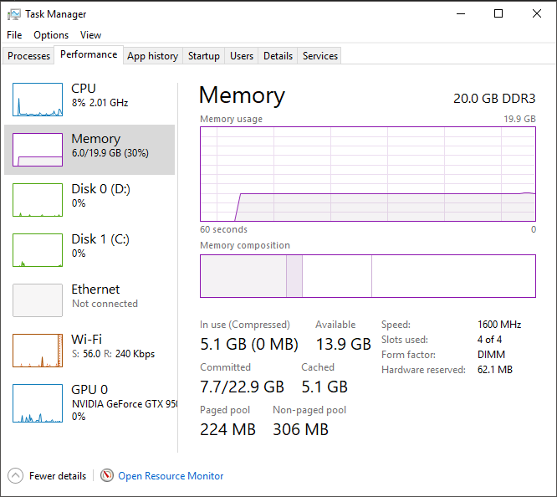Click the Memory tab.
  + - 1. **How to reduce high memory usage**

There are 5 ways:

**1. Registry Hack**

* Hit Win Key + R
* Type in “Regedit” and then hit Enter.
* Go to ‘HKEY_LOCAL_MACHINE\SYSTEM\CurrentControlSet\Control\Session Manager\Memory Management’
* Find ‘ClearPageFileAtShutDown’ and change its value to 1
* 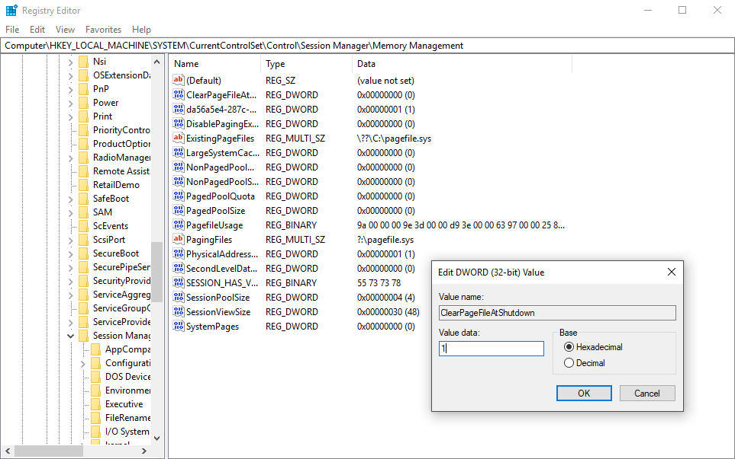Restart the computer.
  + - 1. **Adjust your Windows 10 for the best performance**
* Right click on “Computer” icon and select “Properties.”
* Select “Advanced System settings.”
* Go to the “System properties.”
* Select “Settings”
* Choose “Adjust for best performance” and “Apply.”
* Click “OK” and Restart your computer.

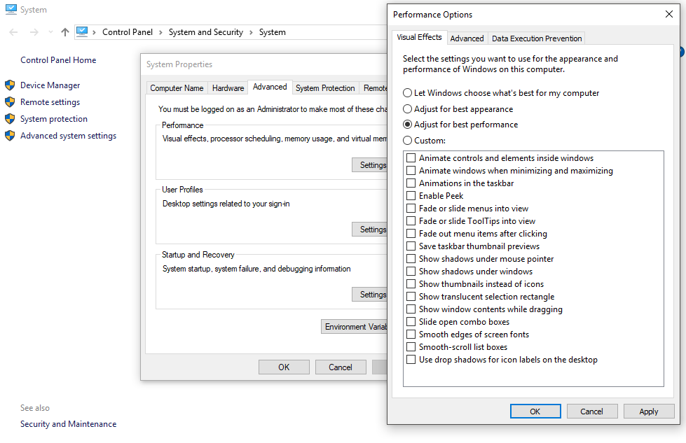

**3. Disable startup programs**

* Hit Win Key + R
* Type ‘msconfig’ and press enter
* The Task manager window will open. Click on the “Startup” tab, and you will see a list of programs that run at startup.
* Right-click on the applications that you don’t want to run at startup and select “Disable”.

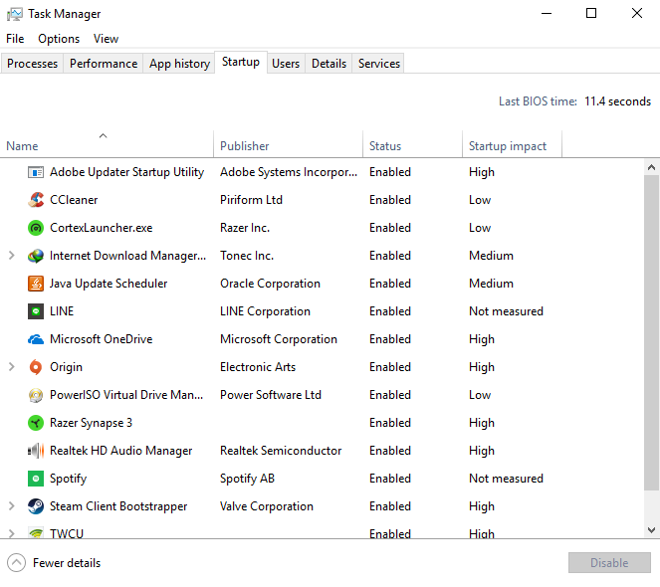

**4. Defragment Hard Drives**

* Hit Win Key + R
* Type “dfrgui” and press enter
* In the new window click on the hard drives you want to defragment (Prefer the drive in which Windows is installed)
* Click “Optimize” and follow the instructions on the screen to finish the defragment process.
* Restart your computer.

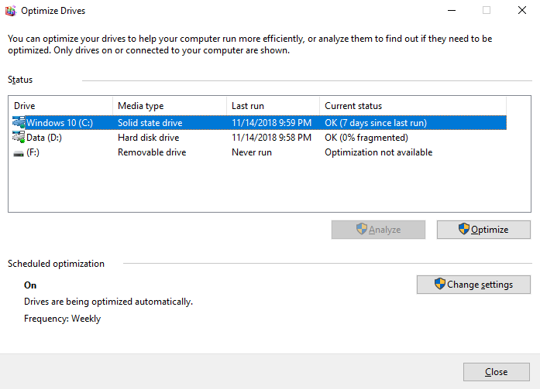

**5. Close and uninstall as many unimportant installed applications as many you can.**

**CHAPTER IV**

**CONCLUSION AND SUGGESTION**

1. **Conclusion**

Linux Mint will continue to be an elegant,100% free operating system and Linux operating system based on the Ubuntu operating system. This operating system offers paid to both companies and individuals.

1. **Suggestion**

Hopefully with the development of increasingly advanced technology, the development of Linux users is also increasing. And this operating system can make it easier for users to install and operate the Linux Mint Operating System.

**BIBLIOGRAPHY**

Utami, Rosiana Budi. “LINUX MINT 9 (ISADORA)”. 10 September 2018. https://www.scribd.com/doc/43943967/MAKALAH-Linux-Mint

Muksidin. “Linux Mint”. 12 September 2018. https://muksidintaslim.com/p/linux-mint_30.html

Rouse, Margaret. “Linux Mint”. 8 September 2018. https://whatis.techtarget.com/definition/Linux-Mint

Rouse, Margaret. “operating system (OS)”. 8 September 2018. https://whatis.techtarget.com/definition/operating-system-OS

Sistem Operasi Komputer. “Kelebihan dan Kekurangan Linux”. 10 September 2018. https://www.sistemoperasikomputer.com/2013/04/kelebihan-dan-kekurangan-linux.html

TechTerms. “Linux”. 8 September 2018. https://techterms.com/definition/linux